HAUNTED FOR HOOTERS ZOMBIE RUN/WALK
PRE-REGISTRATION FORM

NAME_____________________________
PHONE____________________________

SHIRT SIZE (please circle)
Adult Small Adult Medium
Adult Large Adult X-Large
Adult 2X Adult 3X

Please fill out a separate form
for each runner/walker.

Please mail to:
Andover Haunted House
Po Box 415
Andover, NY 14806
By September 25th
to pre-register

Make checks payable to:
Andover Haunted House.
$25.00/person
Please do not send any sponsor money with your
pre-registration fee.

Find us on Facebook or
Online at hauntedandover.com
HAUNTED FOR HOOTERS
5K
ZOMBIE
RUN/WALK
*Get Chased By Zombies..but Don’t Get Caught*

To support breast cancer awareness
All proceeds go to
Allegany County Cancer Services

Starting point at the
Andover Haunted House
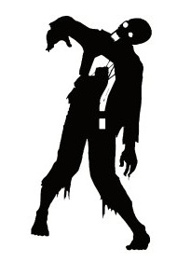
Food and drink provided
at the end of the walk/run

ONLY THOSE WHO
PRE-REGISTER
WILL RECEIVE A
ZOMBIE RUN T-SHIRT
HAUNTED
FOR
HOOTERS
5K
ZOMBIE
Run/Walk

Saturday, October 7th, 2017
Andover Haunted House
5 West Greenwood St.
Andover, NY 14806

$25.00 entry fee/person
Children under 10 walk free with a participating adult.
Registration Time 11am
Run/Walk Time 11:30am

PRE-REGISTER BY
SEPTEMBER 25TH
TO RECEIVE A T-SHIRT

